Aughadreena N.S.
Healthy Eating Policy

Aughadreena N.S. aims to help all those involved in our school community develop positive and responsible attitudes to food choices and to appreciate the contribution that good food makes to health and learning ability. The Department of Education and Skills is supportive of good nutrition as being essential for children’s educational development. Scientific evidence shows there is a significant positive relationship between healthy eating and learning: improving memory, alertness and attention. Healthy eating habits when your child is growing will help to protect your child from possible chronic ill health in teenage and adult years e.g. Type 2 Diabetes, Obesity, Heart Disease and some Cancers. A good variety of nourishing, unprocessed foods are important from the start to ensure a healthy growing child.

- Parents should ensure that children have a balanced breakfast to help them learn and concentrate better in school. Be aware of the high sugar content in some breakfast cereals.

- A healthy lunchbox includes portions of a variety of fresh food from the bottom four shelves of the food pyramid. Processed meats should only be offered once a week. Chicken, turkey, tuna and salmon are good low-fat options. Jam and honey should also be limited due to their high sugar content.

- Some of the healthy snacks that this school encourages for break time include fresh fruit, non-dessert yoghurt, cheese, crackers, plain rice cakes, pitta bread, bagels, wholegrain bread, scones, raw vegetables such as carrot strips, celery, etc. Due to sugar content of raisins they should be kept for lunchtime.

- Healthier choices of drinks are plain water and milk. All pupils are encouraged to bring clear, sports cap bottles of water to school every day which they can avail of throughout the day. Fruit juices/diluted cordials etc should ideally be taken with food therefore they will only be permitted at break and lunch.

- Chewing gum, nuts or any food containing nuts including Nutella and peanut butter, fizzy and diet drinks. Energy/ sports drinks, lollipops, boiled sweets, all cereal bars, winders, all chocolate, fudge and toffee products – this includes flavoured milk dessert/corner yoghurts, bars, etc., buns, biscuits, doughnuts, pastries, cakes etc and crisps are not permitted.

- Nutrition, healthy eating, oral health and physical activity will be included as part of the school SPHE curriculum.

- It is recognised that there are instances where the food provided varies due to the location or the nature of the occasion such as school trips. Food provided on these days should comply with the school food policy.

- Teachers, all staff and parents will provide positive role modelling and support attitudes to encourage healthy eating e.g. using non-food reward system in classrooms and having healthy choices at celebration times.

- The ‘Healthy Eating Policy’ will be reviewed on an annual basis initially and on a two year basis thereafter. It will be circulated to all families and the policy will available on the school website.

In keeping with the Green Schools Initiative which addresses reducing litter and hence protecting the school environment, foods which have wrappers, cling film and tinfoil are to be kept to a minimum and wrappers are to be brought home. Lunch boxes and reusable sandwich bags are encouraged.

Signature: __________________________ Date: ________________
(Chairperson of the BoM)

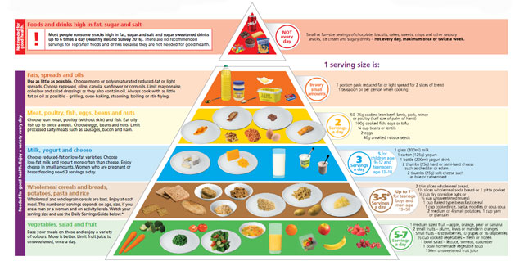

Foods that are Suitable for your Child’s Lunch
- Wholemeal brown bread
- Sandwich filled with meat/cheese/fish/salad
- Pitta bread filled with chicken/tuna/salad
- Pasta salad with tuna/meat/salad
- Wraps/baps/rolls
- Plain rice/oat cakes
- Cheese on crackers
- Scones – wholemeal/brown/fruit/plain
- Fruits (peeled and chopped for infants)
- Vegetable sticks – carrots/celery/cucumber
- Dried fruits – raisins (at main lunch)
- Yogurt
- Cheeses

Foods that cannot be brought to school
- Fizzy drinks
- Chewing gum
- Sweets
- Lollipops
- Winders
- Any chocolate products including chocolate spreads
- Crisps or Popcorn
- Any cereal bars
- Buns
- Biscuits
- Yogurt with chocolate portions
- Nuts. (While nuts are very nutritional, they are not permitted in school due to the possibility of a child having an undetected nut allergy).

